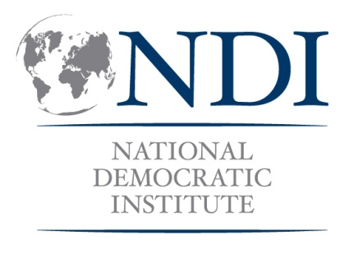
Campaign Training for Women Candidates for Local Council

This training would draw from Campaign Skills 101 (Full Module) and may incorporate sections of other skills (Fundraising, Communications, Leadership) or theory-based modules (Women and Elections, Politics 101, Women and Government) depending on the context. The sample agenda below incorporates multiple modules for a 3-day training workshop. It uses an approach of skill focused breakout sessions where participants rotate through the seven skills sessions over the course of several days.

It can be useful to incorporate sessions with current elected women officials to provide positive examples of women leaders and discuss specific successes and lessons, as well as a session on the election law/campaign regulations to be sure that local councilor candidates are aware of the dates for campaigning and other procedures that need to be followed to remain eligible.

SAMPLE 3-DAY AGENDA
DAY ONE
9:00 Welcome and Opening Remarks
High-level speakers providing introductory remarks and expressing support for the program – TBD based on context.

10:00 Overview of Workshop Objectives and Ground Rules
Depending on the group you may conduct an ice breaker activity here as well.

10:45 Women in Politics
Panel of women elected officials discussing why they decided to run, strategies and advice for approaching leadership about list placement and running a successful campaign, followed by questions and answers.

11:45 Break

12:00 Electoral Framework and Campaign Regulations Overview
Discussion of key aspects of electoral framework and regulations that should be kept in mind when conducting the campaign and reaching out to voters.

1:00 Lunch

2:00 Skill Building Sessions
Group A: Building a Campaign Strategy and Team
Group B: Coalition Building
Group C: Message Development

3:30 Break

4:00 Skill Building Sessions
Group A: Fundraising
Group B: Voter Research/Contact/Targeting
Group C: Public Policy Advocacy

5:30 Wrap up of Day

DAY TWO
9:00 Overview of Day

9:15 Skill Building Sessions
Group A: Coalition Building
Group B: Message Development
Group C: Building a Campaign Strategy and Team

10:45 Break

11:15 Skill Building Sessions
Group A: Voter Research/Contact/Targeting
Group B: Public Policy Advocacy
Group C: Media Interaction/Public Speaking

13:00 Lunch
2:00 Skill Building Sessions
Group A: Media Interaction/Public Speaking
Group B: Building a Campaign Strategy and Team
Group C: Coalition Building

3:30 Break

4:00 Skill Building Sessions
Group A: Public Policy Advocacy
Group B: Fundraising
Group C: Voter Research/Contact/Targeting

DAY THREE
9:00 Overview of Day

9:15 Skill Building Sessions
Group A: Message Development
Group B: Media Interaction/Public Speaking
Group C: Fundraising

10:45 Break

11:15 Skill Building Sessions
Group A: Developing a Campaign Plan
Group B: Developing a Media Strategy
Group C: Developing a Public Advocacy Plan

1:00 Lunch

2:00 Consultations between participants and trainers/elected representatives

3:30 Break

4:00 Final Plenary/Closing Session
Feedback, certificates distributed.

For these final sessions, participants would be able to pick which of these three sessions to attend, as they would not rotate through all of them as they did with the previous skill sessions.

