Negotiation Skills:
Mutual Gains Approach

This is a strategic and systematic approach focused on collaboration among the parties and consensus building to reach an agreement. The process typically follows four steps: Prepare, Create Value, Distribute Value and Follow Through.

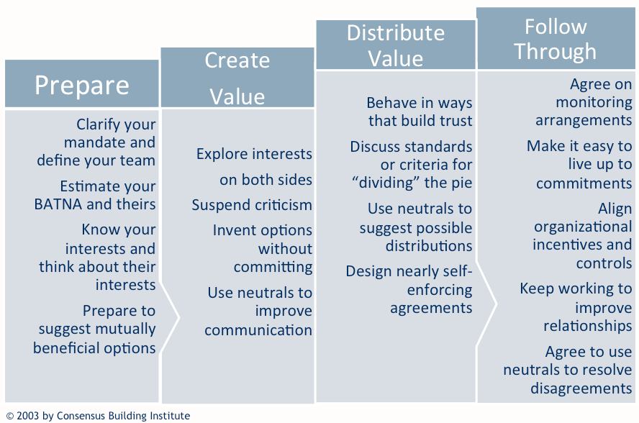

Content from the Consensus Building Institute, www.cbuilding.org.

