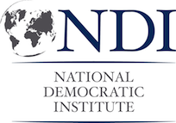
Key Questions for Stakeholder Interviews

- What is the level of women’s involvement in previous elections as voters, election monitors, and election administrators?

- What are the similarities and differences between previous elections and this one?

- What percentages of women are registered and vote in comparison to men? Is there a difference? If so, why?

- What is the track record of how women have participated in the voting process? Have they voted in the same proportion as men?

- Are there unique barriers to women’s electoral participation? Have there been any threats unique to women?

- Have previous elections included voter education programs? Did any specifically target women voters? Have political parties reached their quotas (if they have them)?

