Managing People:
The Delegation Cycle
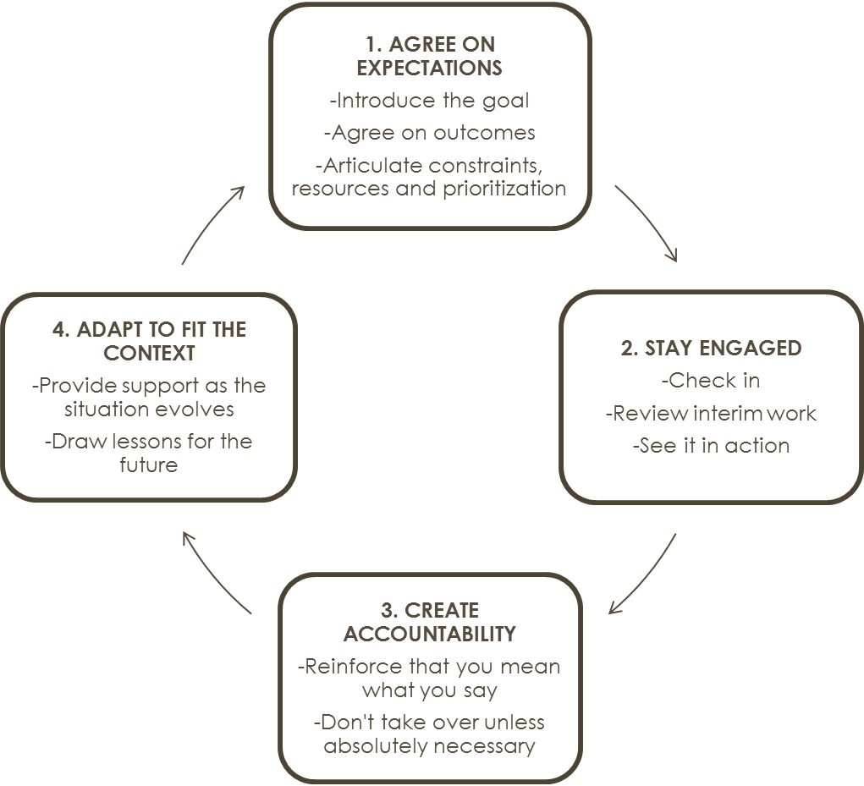

Adapted from Campaigning to Engage and Win, New Organizing Institute (previously adapted from Alison Green and Jerry Hauser, Managing to Change the World)

