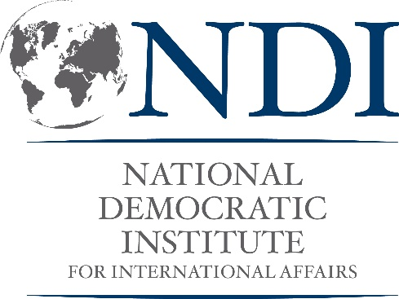

Request for Proposals

Strengthening the Resilience of Women in Politics through Building Capacity to Address Online Violence

Summary
The National Democratic Institute (NDI) is seeking local civil society organizations, informal civic groups, or individual consultants in Fiji, Papua New Guinea, and Solomon Islands to design—in collaboration with NDI—a trauma-informed curriculum and deliver workshops on gendered online violence and resilience strategies for women election candidates, political activists, election officials, and election observers. The program draws on previous research on online violence against women in politics (VAW-P) in the program countries. Vendors may bid on one or multiple countries.

Application

Basic Information
- Organization Name (if applicable)
- Application Date
- Authorized representative(s)
- CVs of key personnel, detailing previous experience and expertise on the training topics and approaches
- Address (personal address, if applying as an individual; organization’s address, if applying as an organization)
- How did you hear about this funding opportunity?

Organizations do not need to be registered in the PICs. However, if you are registered, please provide your registration number: _________________________.

Organization Mission (If applicable)
Please list the mission of your organization (if you are applying as an organization). This does not have to be related to the contract, specifically, but should reflect your values and commitment to the community. (100 words maximum)

Political Context
Provide a brief political overview of the challenges politically active women face in terms of online VAW-P in the country or countries in which you are applying (Fiji, Papua New Guinea, and/or Solomon Islands), as well as opportunities to support them.

Proposed Tasks and Deliverables
Please provide a detailed list of minimum deliverables you can provide, and tasks you will undertake as part of this project.
Sample tasks and deliverables:
- Curriculum development
- Outreach to participants
- Event preparation
- Delivery of workshop session(s)
- Reporting

Be specific: describe the expertise you can provide in developing a training curriculum related to building capacity and creating resilience strategies for women involved in politics who are victims of political violence; your level of access to relevant participants, your outreach approach and anticipated number of participants in the training sessions; and your training delivery methodology.

The safety of all partners and project participants is paramount to NDI. Due to the continuous challenges posed by COVID-19, the project activities will be designed so that they can be delivered either in person, online, or a hybrid format depending on local COVID-19 prevention guidelines and NDI policies in effect at the time when the activity is scheduled to take place.

Past Projects and Experience
Please provide a list of previous projects the organization has worked on relevant to the scope of this program, and how those projects were funded. Please list all relevant projects within the last 3 years.

Budget
Please provide a proposed daily rate for services, inclusive of all expenses (for example, labor cost, office supplies cost, etc.).

Please note that all travel costs associated with future in-person meetings and activities (plane/boat tickets, lodging, per diem and reasonable reimbursement for travel expenses like taxis, etc.) will be covered by NDI. Do not include these expenses in this section.

List of Attachments
Please include the following as attachments to your application:
- Contact information for at least 2 professional references that can attest to past performance on projects of similar scope. The references must include email addresses and phone numbers;
- Name of contract signatory, registration and tax documentation;
- A sample curriculum for this project; and
- Any samples of past relevant work, especially providing trauma-informed capacity building within the cultural context when conducting training related to violence against women.

Disclosure and Certification
Please provide disclosure of any known past, present or future relationships with any parties associated with NDI. For example, bidders should disclose if a member of their Board is also a member of NDI's Board currently or in the past, or if they are affiliated (such as a board member, current/past employee or family member, volunteer, etc.) with a civil society organization that is a current, past or planned recipient of NDI funding.

Please also certify in this section that the prices offered were arrived at independently and without the purpose of restricting competition with other offerers, including but not limited to subsidiaries and that prices have not been and will not be knowingly disclosed to any other offerer unless required by law.

Failure to comply with these requirements may result in NDI having to re-evaluate the selection of a potential bid.

