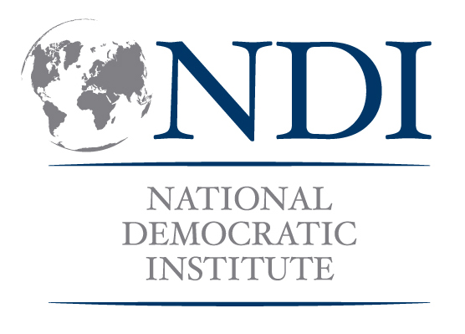

Pre-Nomination Workshop for Women Candidates

This training would draw from Politics 101 (Government Structures); Communications (Public Speaking, Messaging); Campaign Skills 101 (Full Module); and Leadership 201 (Personal Message). Depending on the context, it might also draw on Women and Elections, Women and Political Parties, and additional leadership presentations and other skill modules as appropriate.

In addition, it will be important to address the challenges for women taking part in politics, but these will vary by context. Ensure that the particular barriers are covered in the training. (For example: here the focus is primarily on strategies for convincing party leadership. It may be that the barriers are financial, that resistance is from the family, and/or that women lack confidence and assertiveness to engage in public life and are therefore dissuaded to engage politically.)

SAMPLE 2-DAY AGENDA

DAY ONE

9:00 Welcome and Introductions

9:30 Overview of Electoral Timetable
This could also be expanded to cover the role of government or specific aspects of the electoral process that need to be highlighted.

10:00 Getting Ready to Run (Part I)
Brief introduction/refresher of campaign basics: Researching your constituents’ priorities, setting goals, and voter contact.

10:30 Break

11:00 Getting Ready to Run (Part II)
Brief introduction/refresher of campaign basics: Targeting voters and developing the campaign message.

12:30 Lunch

1:15 Challenges for Women in Politics
Discussion of particular barriers within the context – this can be expanded to the focus of subsequent sessions as well to get more into the strategies for overcoming barriers. It would be useful to engage local resource persons here who can speak to their experiences as candidates, etc. in previous elections.
2:00 Getting Nominated
How to approach party leadership/arguments and strategies to convince party leadership that they should nominate women (you specifically).

3:00 Break

3:30 Promoting Yourself: Persuasion, Message Development, Public Speaking and Campaign Bios (part 1)
Crafting the message you will use to convince your party’s leaders to nominate you, and reviewing public speaking tips and techniques to use when speaking with them; how to write a stand-out bio for your campaign.

Homework: Draft a bio based on today’s discussions

DAY TWO

9:00 Promoting Yourself, continued

10:30 Break

10:45 Promoting Yourself: Message Development, Public Speaking and Campaign Bios (part 2)
Continue practicing the message you will use to convince your party’s leaders to nominate you, peer review of bios.

12:30 Lunch

1:30 Making the Plan
Setting down a concrete plan for your meetings with party leaders and stakeholders to get that nomination – including who you will meet, what you will say and when you will meet them.

3:15 Break

3:30 Panel Discussion with Women Candidates and Party
Representatives
A discussion with party leadership and women who have run
successful campaigns.

5:00 Conclusion and Certificate Ceremony

