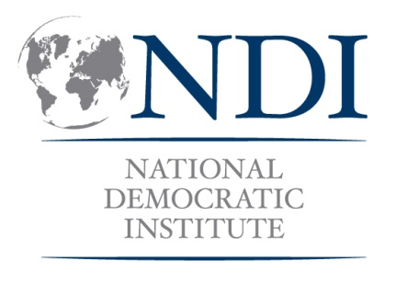
Strategic Planning for Political Party Members/Women’s Wing

This training would draw primarily from the Political Parties Module (Increasing Women’s Leadership in Political Parties) and the Planning and Organizational Development presentation (within the Management Toolbox Module). Other topics and skill areas may be included depending on the context (coalition building, gender analysis, etc.). The sample agenda below is for women political party members interested in establishing/strengthening a women’s wing within their party. Depending on the context, you might want to start with a foundational session using the Political Parties 101 presentation to cover the role and function of political parties in a democracy. Aspects of the Leadership 201 module might also be helpful in thinking about vision, mission, goals, etc. but adapted for discussion at the organizational level. All or portions of the Advocacy, Coalition Building, Research and Negotiation Module may also be useful to incorporate.

If the women’s wing is already established, the first day’s agenda could be condensed to go into strategic planning on day one, or could be reworked to talk through the current status of the women’s wing (challenges, strengths, opportunities, etc.) to lead into the strategic planning discussions. This workshop may be conducted with single or multi-party participants, depending on the context. If multi-party, it will be important to include time for group work so that participants can spend time planning with members of their own party. Spend time working with the group on their particular stage and challenges, such as the legal framework/structure, fundraising, or recruiting and retaining members, in addition to their priorities for policy work.

SAMPLE 2-DAY AGENDA

DAY ONE

9:00 Registration

9:30 Overview of Women’s Participation in Political Parties
Current statistics, benefits/reasons for women to become active members and leaders in their parties

10:00 Barriers to Women’s Participation in Political Parties
Barriers to joining, actively participating and accessing leadership positions in parties.

10:45 Break

11:00 Why Form a Women’s Wing
Women’s wings bring together women members of the party and provide a space to identify political issues and party policies that are most salient to women voters. Discuss benefits and challenges of women’s wings.

11:30 How to Form a Women’s Wing
      - Developing a critical mass of interested women, approaching party leadership for support, requesting to add to official party meeting agenda, etc.
      - Thinking through relationship between the women’s wing and party, national and local level, membership and leadership

1:00 Lunch

2:00 Roles of a Women’s Wing
Brainstorm activities, including: mobilizing voters, training members, linking with civil society, identifying needs of women constituents, promoting women’s leadership in the party, influencing party platform, etc.

3:00 Break

3:15 Group Discussions on Women’s Wing Formation
Facilitated discussions with political party members on the aspects of forming a women’s wing.

4:30 Wrap up of Day

DAY TWO

9:00 Overview of Day

9:15 Introduction to Strategic Planning
- Why plan? What are the steps to strategic planning?
- Identify:
  - Goals/priorities
  - Resources
  - Timeline
  - Roles

10:00 SWOT analysis
Identifying Strengths, Weaknesses, Opportunities and Threats.
SWOT Group Work

11:00 Break

11:15 Group Discussion and Strategic Planning
Discussion. What issues arise out of this analysis? What are the critical questions for the group to answer? What are the SMART objectives that the group might set arising from this analysis?

12:00 Developing a Strategic Plan
Building on the SWOT analysis and objectives: How can the group work together to achieve these objectives? Who will be responsible for what?

1:00 Lunch

2:00 Strategic Planning, continued

3:15 Break

3:30 Group Presentations

4:30 Closing Session and Evaluations

